9.2 CV09 — Cleaner Removes Material, But Containment Still Fails
[evaluate if these two paragraphs need to be softened?]
CV09 demonstrates a different failure mode. The existing cleaner is outside/open to the effective head-chute discharge containment arrangement. It removes some wet residual material, but successfully removed material can fall directly into the surrounding plant area while residual carryback can continue onto the return run.[I want to expand the last sentence by also adding that the carry back not only pollutes/escapes to the environment below but carries down to the screen plant section populating the floor and surrounding sections of the screen levels where the conveyor tailed overlaps with the screen plant. ] Active wet-material fallout was recorded during operation. CV09 is therefore a useful pilot for proving belt cleaning and containment as one integrated control function.[I want to also expand this sentence by also defining that this belt is one of the area where if the proposed solution is piloted will have high impact in solving/reducing fines spillage]
The accepted functional objective is to remove residual fines before the belt enters the return run, with the cleaner acting while the belt is positively supported by the head pulley and with the cleaner stages located inside the existing head/discharge chute. This allows scraper-removed fines to fall naturally into the existing combined-product discharge flow rather than requiring a separate fines-recovery chute. Site geometry, mounting, access and the final OEM arrangement still require verification and detailed design.
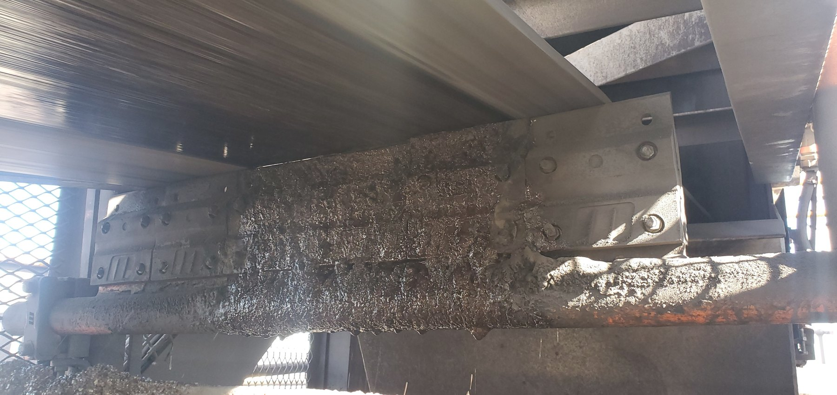  CV09-REF-003 — principal still showing the cleaner/open local arrangement. |  | 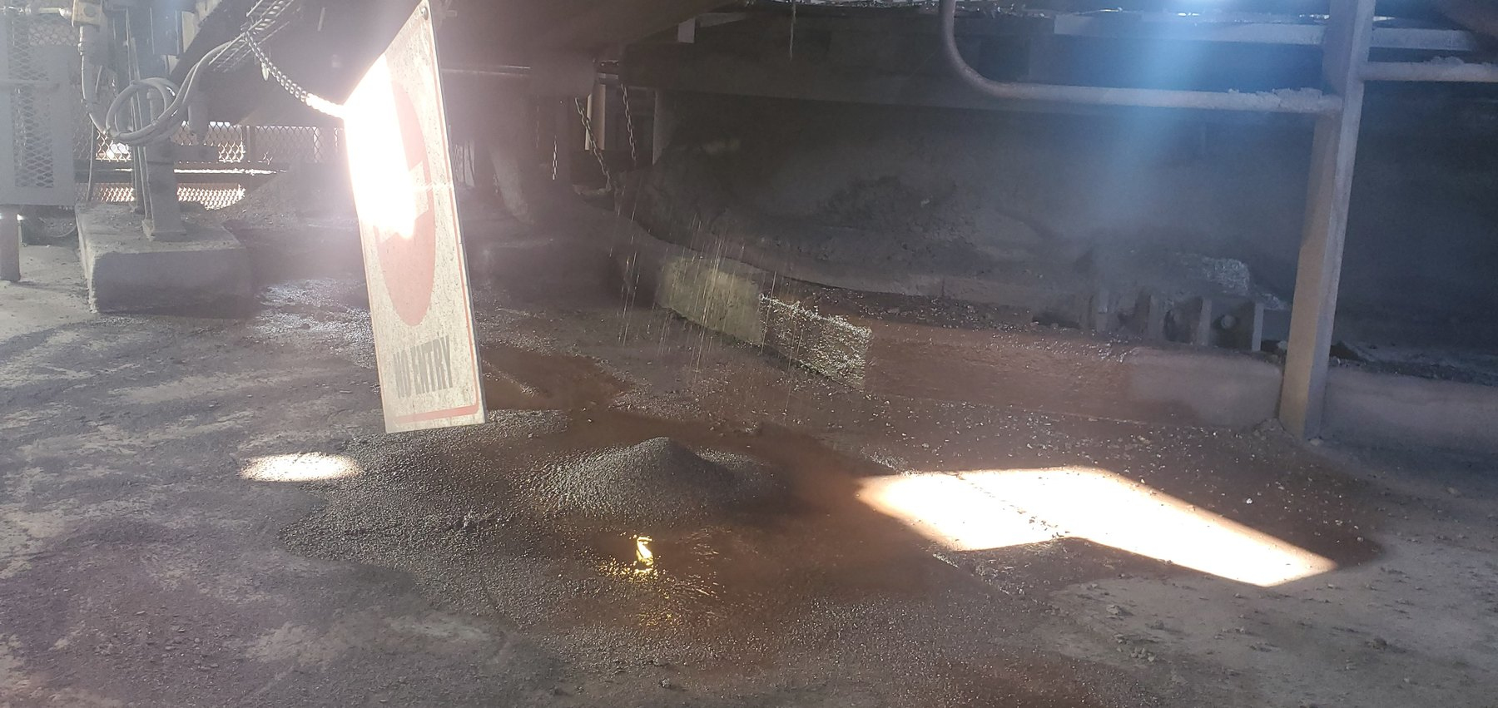  CV09-REF-002 — wet-fines/slurry consequence below the discharge/cleaner region.
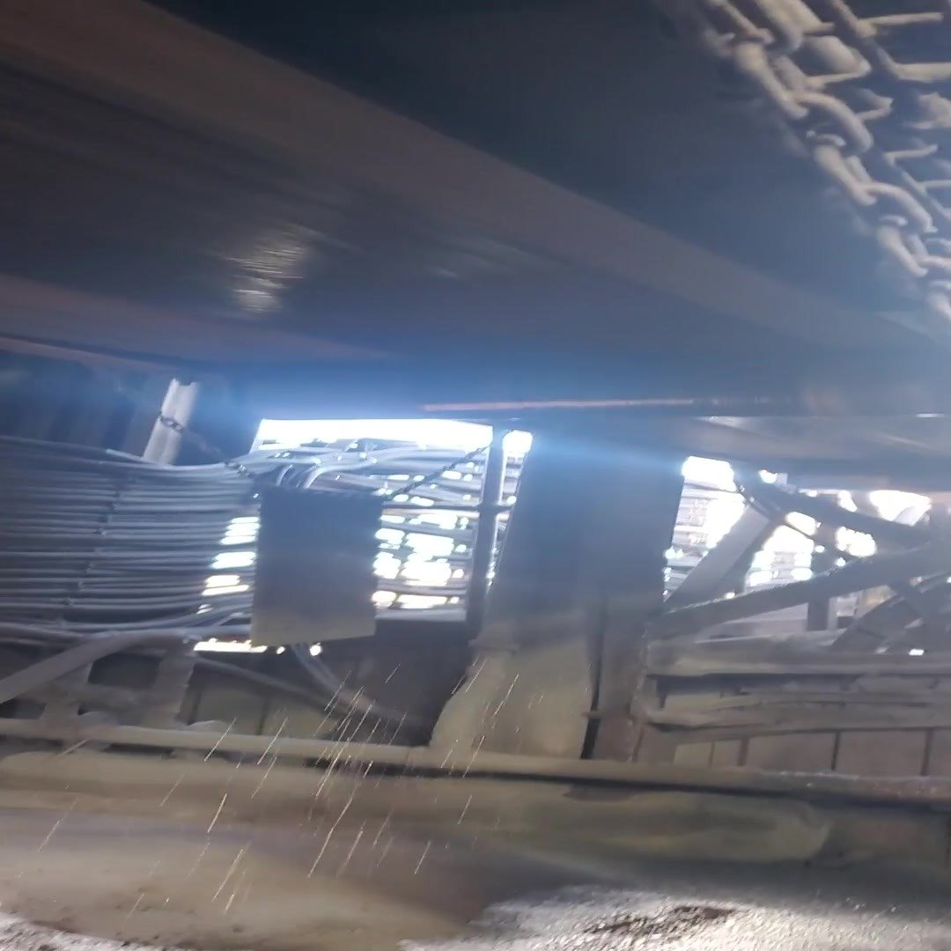  CV09-REF-006 — representative frame from inspection video showing active wet-material fallout during operation. |  | 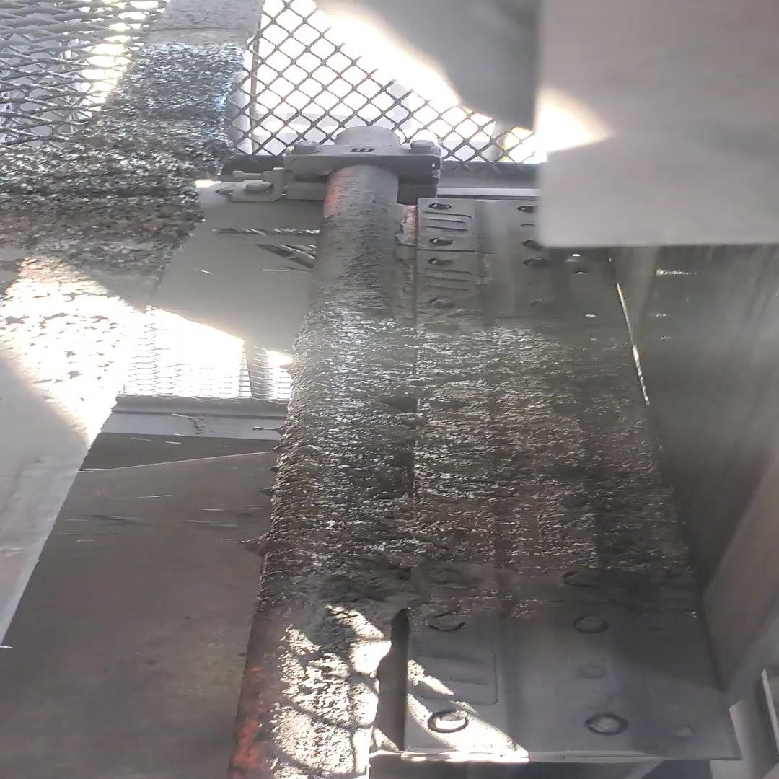  CV09-REF-008 — representative frame from inspection video showing contaminated cleaner/chute geometry relevant to the containment-boundary issue and pilot concept.
OBSERVATION | Wet fines/slurry are present below CV09 and active wet-material fallout was recorded during operation.
ENGINEERING ASSESSMENT | The existing cleaner can remove material from the belt, but its open/outside relationship to the effective head-chute containment allows successfully removed wet fines to become plant-area spillage. Residual carryback also remains possible downstream. Final OEM geometry and component detail remain open.
CONTROL PHILOSOPHY | Do not merely clean the belt. Keep the fines inside the process.
RECOMMENDED NEXT ACTION | Develop and trial the locked CV09 functional concept from verified site geometry: pulley-supported cleaning inside the head/discharge chute, preferred two-stage cleaning where feasible, controlled self-tensioning/wear compensation, positive travel limitation, practical maintenance access, and representative operating verification.

